Project Design Phase-II
Technology Stack (Architecture & Stack)

Date | 15 February 2026
Team ID | LTVIP2026TMIDS80893
Project Name | Rainfall Prediction System for Agriculture
Maximum Marks | 4 Marks

Technical Architecture
The system follows a layered architecture consisting of User Interface layer, Application Logic layer, Machine Learning layer, and Data Storage layer. The frontend collects weather parameters, the Flask backend processes the data, applies preprocessing, and invokes the trained Random Forest model to generate rainfall prediction and advisory.
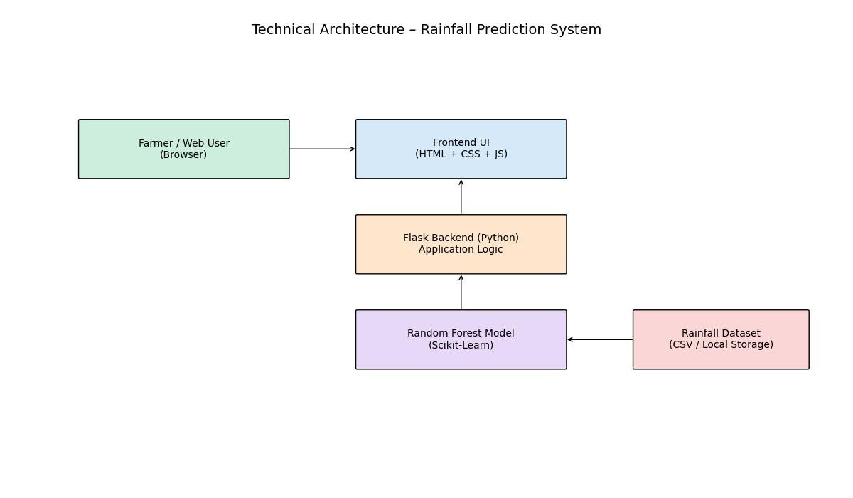

Table-1 : Components & Technologies

S.No | Component | Description | Technology
1 | User Interface | Web interface for user input and displaying prediction results | HTML, CSS,  JavaScript
2 | Application Logic-1 | Backend server logic handling requests and routing | Python (Flask  Framework)
3 | Application Logic-2 | Data preprocessing  (Scaling, Encoding,  Imputation) | Scikit-learn, Pandas,  NumPy
4 | Machine Learning  Model | Rainfall prediction using classification  algorithm | Random Forest  (Scikit-learn)
5 | Database / Data  Storage | Rainfall dataset storage for model training | CSV File / Local  Storage
6 | Model Storage | Serialized trained model file | Pickle (.pkl files)
7 | Infrastructure  (Server) | Application deployment environment | Local System / VS  Code / Jupyter

Table-2 : Application Characteristics

S.No | Characteristics | Description | Technology
1 | Open-Source  Frameworks | Open-source tools used for development | Flask, Scikit-learn,  Pandas, NumPy
2 | Security  Implementations | Input validation and secure backend processing | Flask validation, Python error handling
3 | Scalable  Architecture | Modular structure allowing future cloud deployment | Flask + Microservice ready structure
4 | Availability | Web application accessible via browser | Localhost /  Deployable to Cloud
5 | Performance | Fast prediction (within seconds) using optimized model | Random Forest optimized model

